Sample in each age group (127 18-21 year olds, 85 teens) , from around the Philadelphia area. **Correlations:   
  
Adults**:  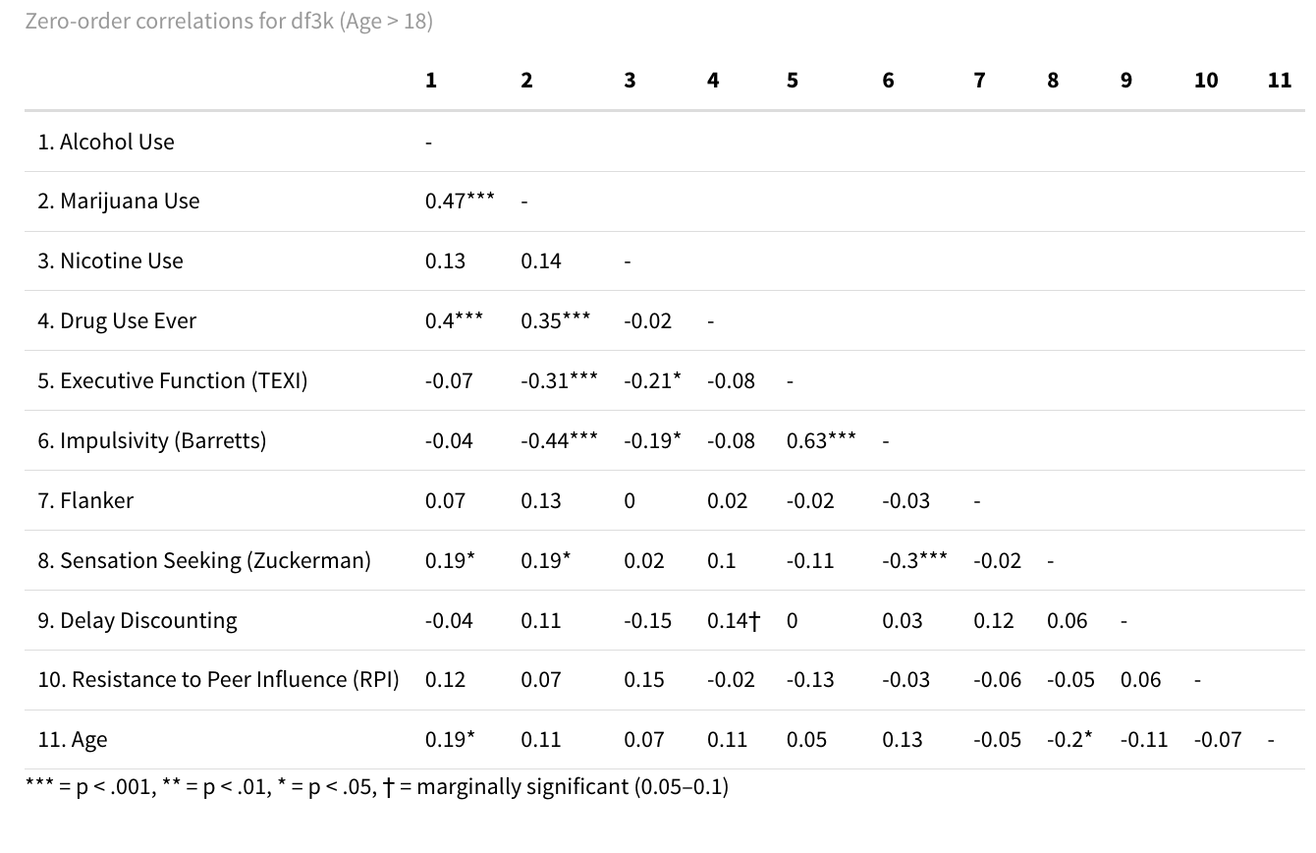

**Teens:**

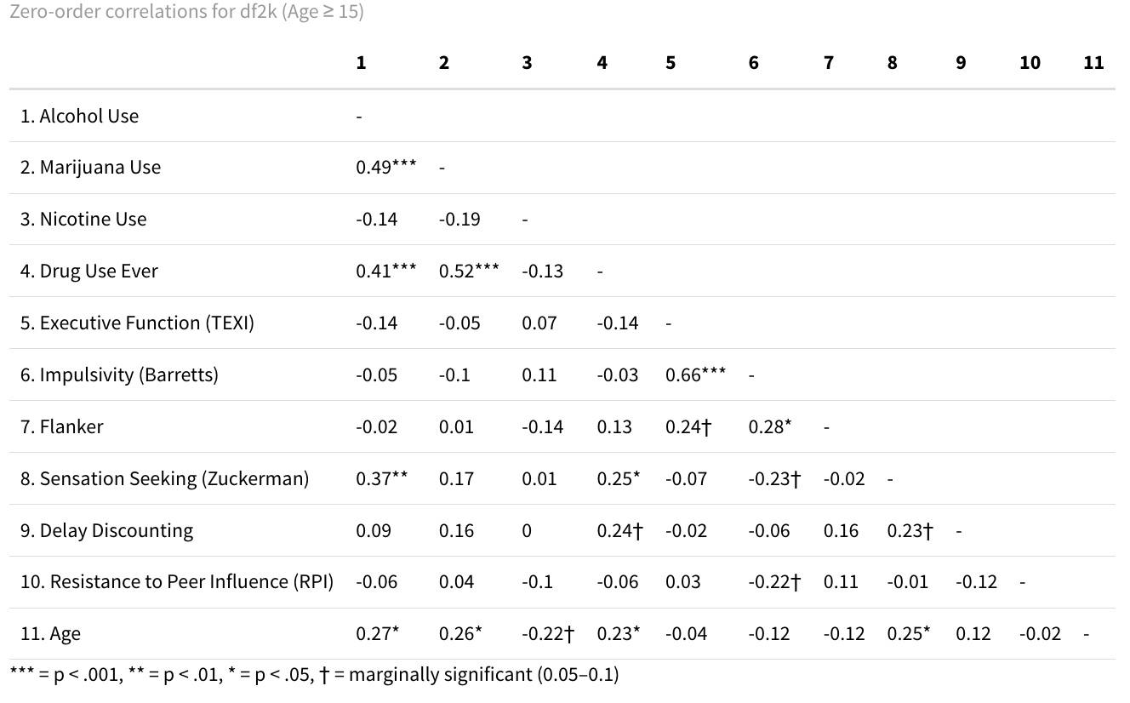

**Shapley   
  
Adults 🡪**

**Predicting Alcohol Use:**

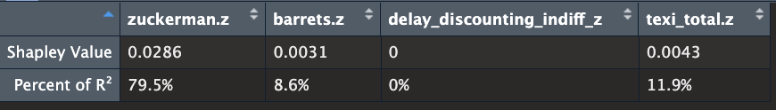

**Predicting Weed Use:**

**Predicting Nicotine Use: (ADULTS)**

**Teens 🡪**

**Predicting Alcohol Use:**

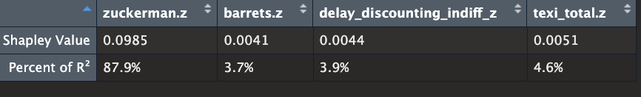

**Predicting Weed Use:**

**Predicting Nicotine Use:  
  
**

**Splitting Weed/Alcohol use into high (frequent) vs. low (never/light use)  
  
Double checking that this doesn’t create a big age difference between catgeories – it doesn’t:   
  
**

**Movas with Age X Moderator**

| **Substance Use Group** | **Multivariate Effect** | **Interaction with Age** | **Significant Univariate Effects (FDR-corrected)** | **Interpretation** |
| --- | --- | --- | --- | --- |
| **Weed Use** | Yes (Pillai = .13, p < .001) | No (p = .49) | - Barretts (Impulsivity): padj = .000- TEXI: padj = .006- Zuckerman: padj = .027 | Strong cognitive differences between high and low weed users, especially in impulsivity, EF, and sensation seeking. Effects are not moderated by age. |
| **Alcohol Use** | No (p = .20) | Yes (Pillai = .063, p = .022) | - Zuckerman × Age interaction: padj = .099 † | No main cognitive differences across alcohol use groups, but age moderates the relationship with sensation seeking. Effect is trending in younger individuals. |
| **Nicotine Use** | No (Pillai = .003, p = .98) | No (Pillai = .004, p = .95) | None significant (all padj > .97) | No evidence for cognitive differences based on nicotine use group, nor moderation by age. |

**Slope Analysis on Alochol and age to see where break in significance happens:**

| **Age Level** | **Slope of Alcohol → Zuckerman** | **p-value** | **Interpretation** |
| --- | --- | --- | --- |
| **Age 16.3** (-1 SD) | **1.06** | **< .001** | Strong, significant positive association |
| **Age 18.1** (Mean) | **0.51** | **< .001** | Moderate, significant positive association |
| **Age 19.8** (+1 SD) | -0.04 | 0.85 | No association |